Name -Hritik Kumar
Tasks
Objective Questions:

- What is the total no. of attributes present in the data?
Ans -There are 10 attributes in the Tickets dataset.
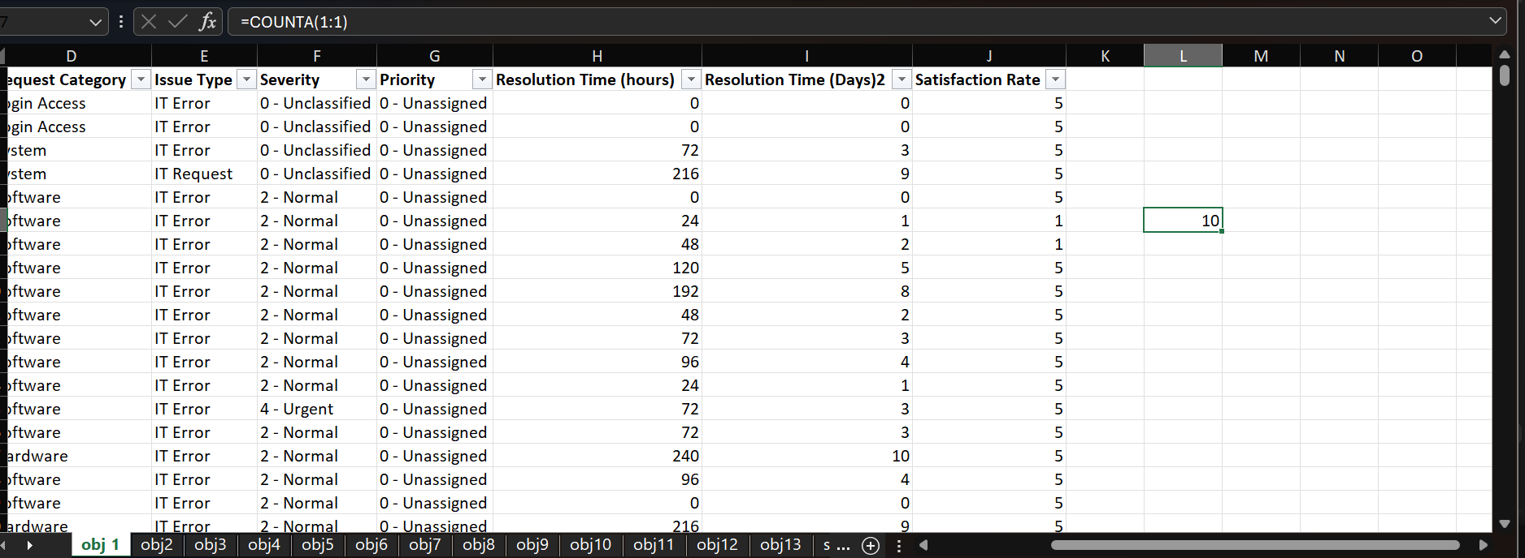
🟦 Approach Used:
- The dataset was opened in Microsoft Excel.
- Checked the header row (Row 1) to identify all column names.
- Used the =COUNTA(1:1) formula to count the total number of columns (attributes).
- Verified that there are 10 attributes in total.

🟦 Insights:
- The dataset contains 10 important details about tickets such as ID, Agent, Issue Type, Status, Priority, and Rating.
- These attributes help analyze performance and customer satisfaction effectively.

🟨 Recommendations:
- Keep column names clear and uniform.
- Use data validation to reduce entry errors.
- Add extra columns like Resolution Time for better analysis.

- Which columns have inconsistent or missing values, and what is the count of such values?
Ans- No columns have missing values in this dataset.
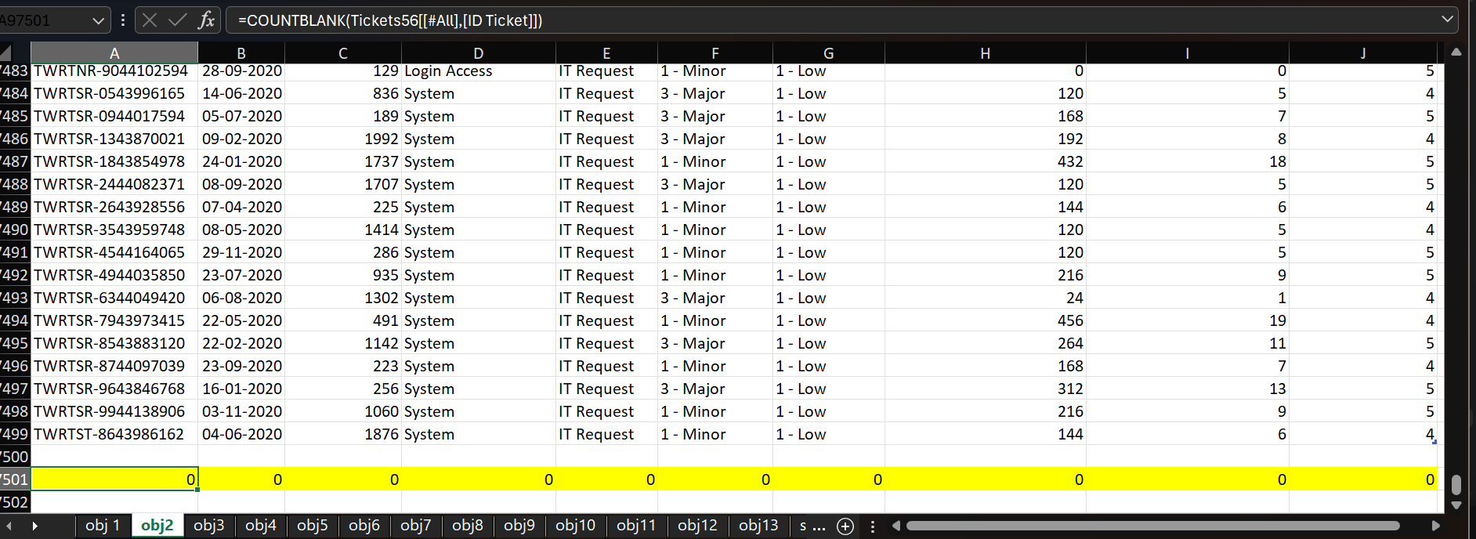
🟩 Approach Used:
- Opened the dataset in Excel.
Used Excel formulas like: =COUNTBLANK(A:A)
for each column to confirm there are no blank cells.

🟦 Insights:
- The dataset is clean and complete, which means it’s ready for analysis without any data cleaning needed.
- Having no missing values ensures accurate results in Pivot Tables, charts, and formulas.

🟨 Recommendations:
- Keep performing regular data checks before analysis.
- Use data validation to prevent missing or incorrect entries in future records.
- Maintain a clean master copy of the dataset for backup.

- What is the average daily ticket volume over time?
Ans - Avg daily ticket volume = 53.36507937
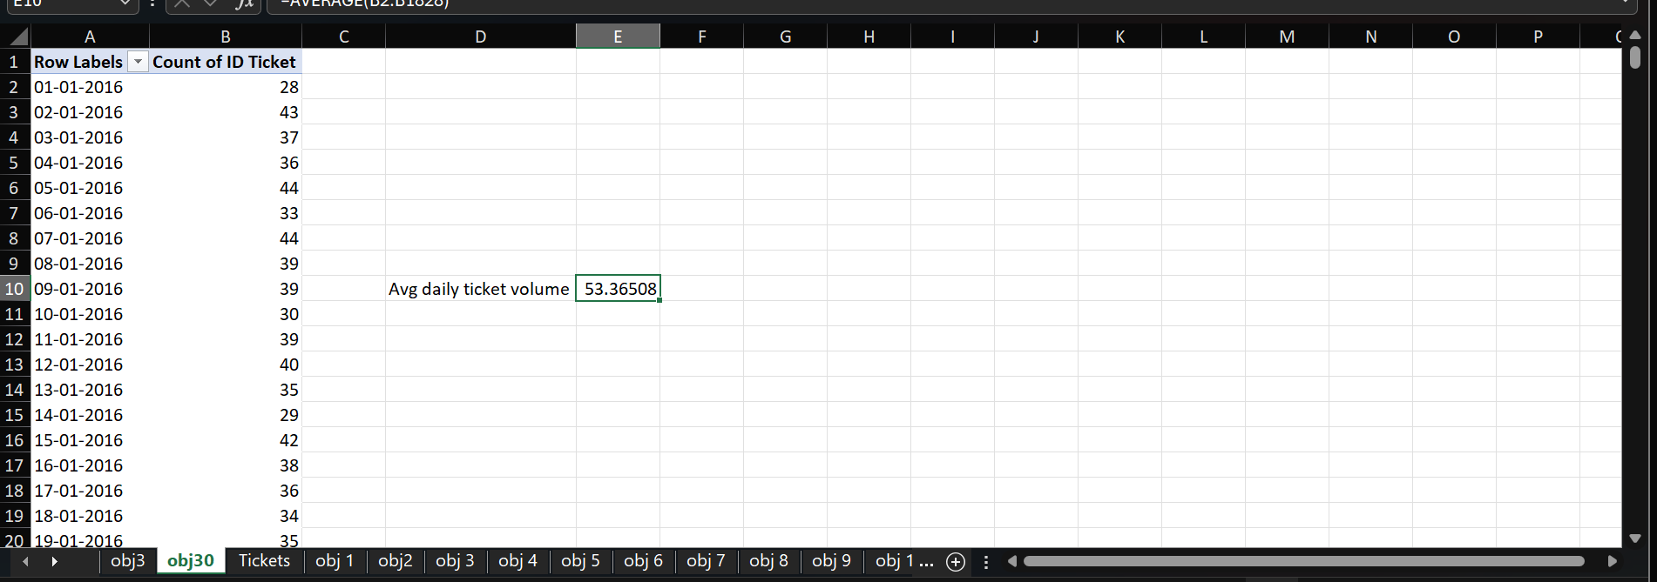
🟨 Approach Used:
A Pivot Table was created using:
- Rows: Date (Ticket Created Date)
- Values: Ticket ID (Count)
Then, the average of daily ticket counts was calculated.

🟨 Insight:
The average daily ticket volume is around 53 tickets per day, showing a consistent flow of requests over time.

🟨 Recommendation:
Ensure the support team has sufficient staffing to handle around 50–60 tickets daily efficiently and maintain timely resolutions.
- What is the distribution of ticket categories (e.g., Login Access, System, Software)?
Ans -
the distribution of ticket categories
- System → 39,002 tickets
- Login Access → 29,193 tickets
- Software → 19,570 tickets
- Hardware → 9,733 tickets
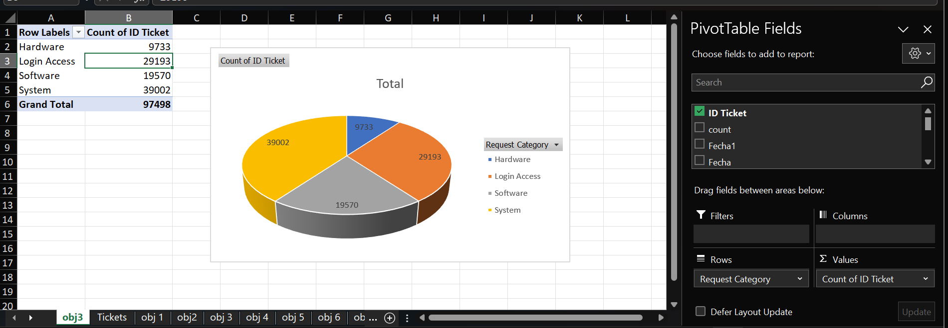

🟨 Approach Used:
A Pivot Table was created to analyze the ticket distribution.
- Rows: Request Category
- Values: Ticket ID (Count)
🟨 Insight:
Most tickets are from the System category, followed by Login Access, while Hardware issues are the least reported.
🟨 Recommendation:
Prioritize improving system performance and login access management to reduce the high number of related tickets.

- How many tickets has each agent handled?
Ans-
Row Labels | Count of ID Ticket
1 | 1969
2 | 1968
3 | 2021
4 | 1988
5 | 2000
6 | 1949
7 | 1935
8 | 1960
9 | 1949
10 | 1974
11 | 1956
12 | 1897
13 | 1856
14 | 1942
15 | 1991
16 | 1926
17 | 1961
18 | 1892
19 | 1984
20 | 1920
21 | 1889
22 | 1966
23 | 1915
24 | 2003
25 | 1906
26 | 1963
27 | 1968
28 | 1946
29 | 1931
30 | 1963
31 | 1987
32 | 1974
33 | 1958
34 | 1927
35 | 2007
36 | 1913
37 | 1931
38 | 1938
39 | 2026
40 | 1920
41 | 1966
42 | 1945
43 | 1897
44 | 1943
45 | 1929
46 | 1950
47 | 1933
48 | 2027
49 | 1890
50 | 1949

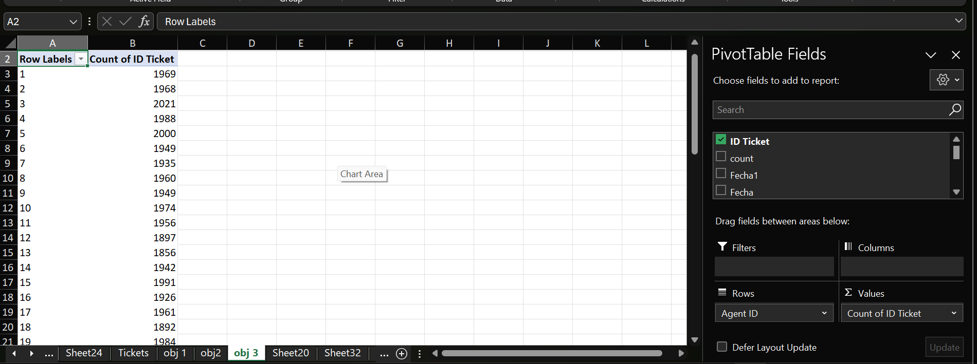

Each agent has handled between 1,856 and 2,027 tickets.
The detailed ticket count for all 50 agents is shown below.

🟩 Approach Used:
- Opened the dataset in Excel.
- Inserted a Pivot Table:
  - Rows → Agent ID / Name
  - Values → Count of Ticket ID
- This showed the total number of tickets handled by each agent
🟦 Insights:
- All agents handled a similar volume of tickets, showing a balanced workload distribution.
- The highest number of tickets handled: Agent 48 (2027).
- The lowest number of tickets handled: Agent 13 (1856).
- This indicates good task distribution with only slight variations among agents.

🟨 Recommendations:
- Continue maintaining an even workload among agents to ensure consistent performance.
- Monitor agents with lower ticket counts to check for efficiency or availability issues.
- Recognize top-performing agents for motivation and team morale.

- How can you extract the domain from the email addresses in the IT Agents sheet?
Ans-
You can extract the domain from email addresses using this Excel formula:
=RIGHT(Email, LEN(Email) - FIND("@", Email))
This formula returns the domain part of the email (e.g., gmail.com, yahoo.com).

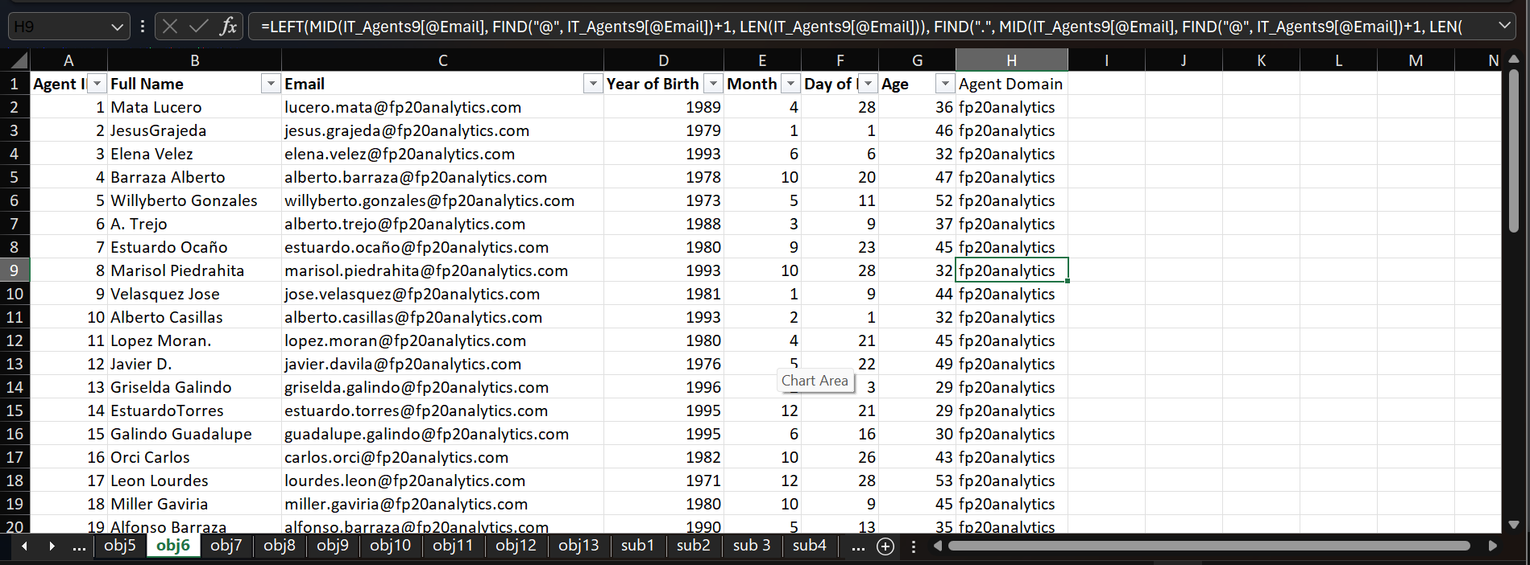

🟩 Approach Used:
- Selected the column containing email addresses.
- Applied the above formula in a new column.
- The FIND function locates the “@” symbol, and RIGHT + LEN extracts the text after it.

🟦 Insights:
- The formula helps quickly identify which email service provider (like Gmail, Outlook, etc.) agents use.
- Useful for analyzing communication platforms or verifying official vs. personal domains.

🟨 Recommendations:
- Use Text to Columns (Data tab → Delimited → “@”) for quick extraction if many emails exist.
- Ensure no extra spaces or invalid email formats before applying the formula.
- Can also use LOWER() with the formula to standardize all domains in lowercase.

- How can you find the full name of an agent given their Agent ID?
Ans-
To find the full name of an agent using their Agent ID, you can use this Excel formula:
=VLOOKUP(Agent ID, 'IT Agents'!A:B, 2, FALSE)
This formula will return the agent’s full name from the IT Agents sheet.
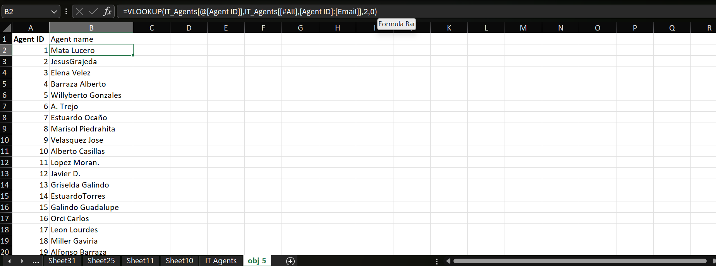

🟩 Approach Used:
- Used the VLOOKUP function to match the Agent ID from the main dataset with the IT Agents sheet.
- Specified column 2 to fetch the corresponding full name.
- Used FALSE for an exact match.

🟦 Insights:
- The formula helps quickly link Agent IDs with their names across sheets.
- Useful for combining or referencing data without manual lookup.

🟨 Recommendations:
- Ensure both sheets have unique Agent IDs to avoid mismatches.
- Keep the IT Agents sheet updated so lookups return correct names.
- For large datasets, consider using XLOOKUP (for Excel 365 or 2021) for easier and more flexible lookups.

- What is the count of each issue type (e.g., IT Error, IT Request)?
Ans-
Row Labels | Count of ID Ticket
IT Error | 24278
IT Request | 73220
Grand Total | 97498

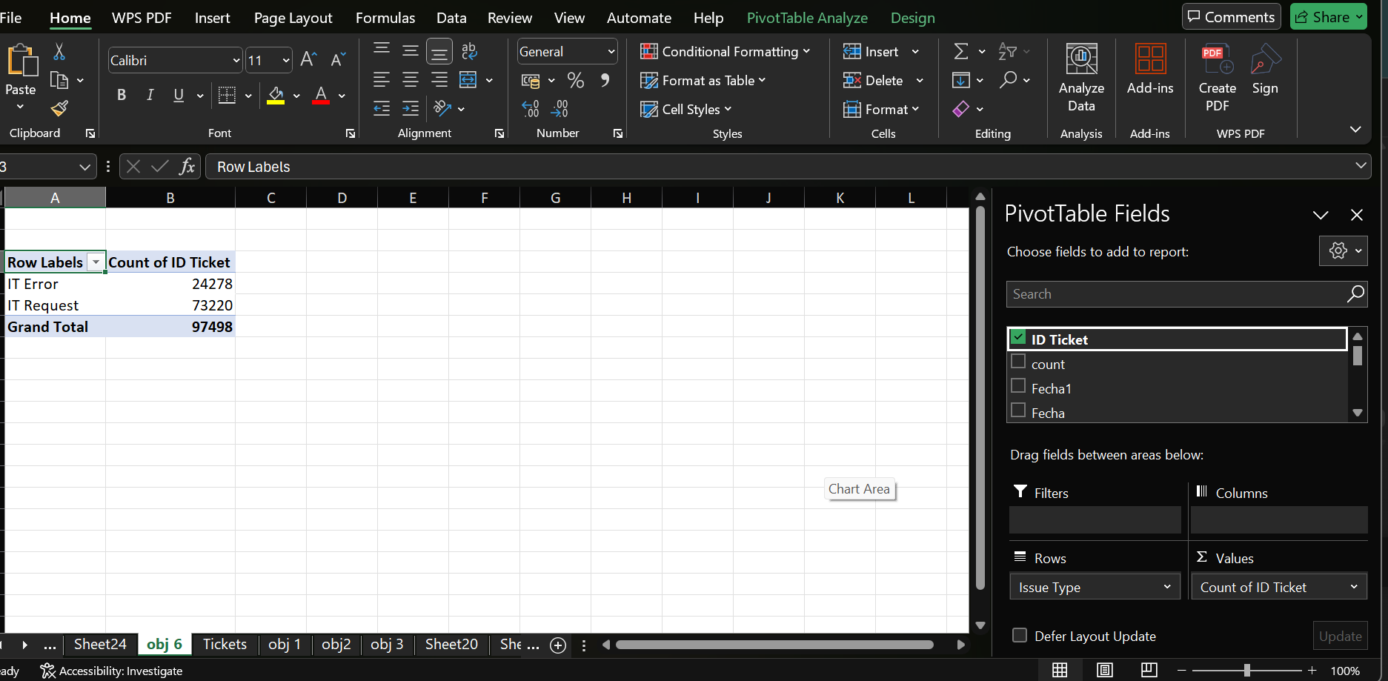

🟨 Approach Used:
- Opened the dataset in Excel.
- Created a Pivot Table:
  - Rows → Issue Type
  - Values → Count of Ticket ID
- This counted how many tickets fall under each issue type.

🟦 Insights:
- IT Requests make up the majority of tickets (around 75%).
- IT Errors are fewer but still significant, showing areas for system improvement.

🟨 Recommendations:
- Analyze common IT Request categories to find repetitive user needs.
- Review IT Error tickets to identify recurring technical issues.
- Prioritize automation or self-service solutions for frequent request types.

- What is the daily average resolution time for tickets?
Ans- The average daily resolution time for tickets overall years is approximately 4.55 days.
Resolution times are quite stable over the years, varying slightly between 4.52 to 4.59 days annually.
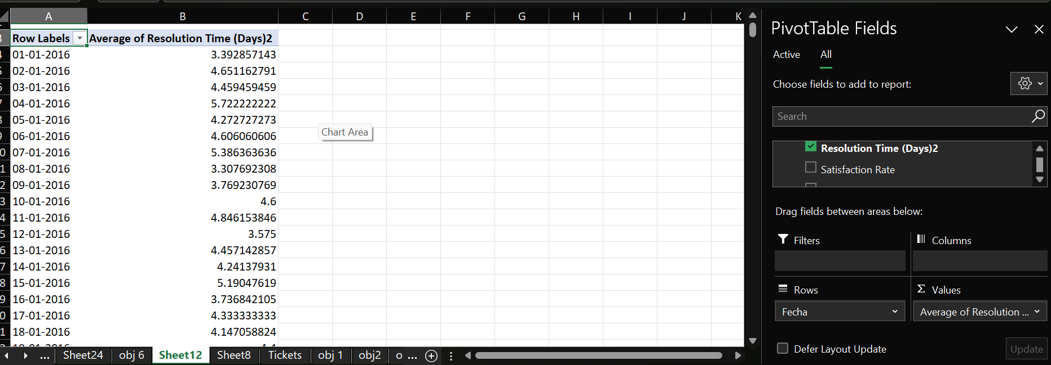

🟩 Approach Used:
- Used Excel to calculate the average resolution time.
- Formula used:
- =AVERAGE(Resolution_Time)
- Also used a Pivot Table with Year in rows and Average of Resolution Time in values to compare across years.

🟦 Insights:
- Ticket resolution performance is consistent across years.
- No major fluctuations indicate a steady service process.

🟨 Recommendations:
- Maintain the same workflow to keep resolution times consistent.
- Identify factors that help achieve this stability and apply them to high-priority cases.
- Explore automation or training to reduce the average time further below 4.5 days.

- How has the volume of tickets changed over time?
Ans-
The volume of IT support tickets has steadily increased over the years.
- In 2016, there were 13,051 tickets.
- This grew consistently, reaching 29,088 tickets by 2020.
- The highest number of tickets was observed in 2020, almost double compared to 2016.

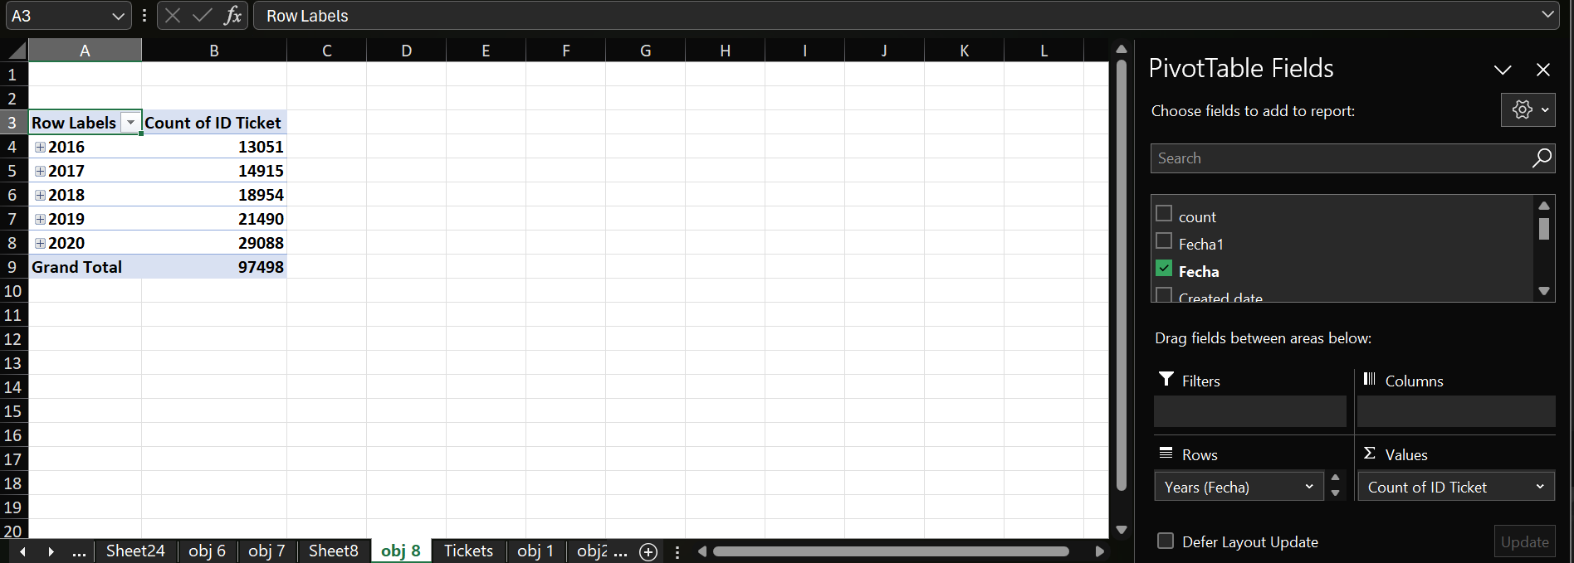
🟩 Approach Used:
- Used Pivot Table in Excel:
  - Rows → Year
  - Values → Count of Ticket ID
- Created a Line Chart to visualize how ticket volume has changed each year.

🟦 Insights:
- There is a consistent upward trend in ticket volume from 2016 to 2020.
- This suggests growing IT system usage or expansion of services/users.

🟨 Recommendations:
- Plan for more IT staff or resources to manage the growing ticket volume.
- Use automation tools or chatbots for common IT requests.

- What is the average age of the IT agents?
Ans-
40 years old
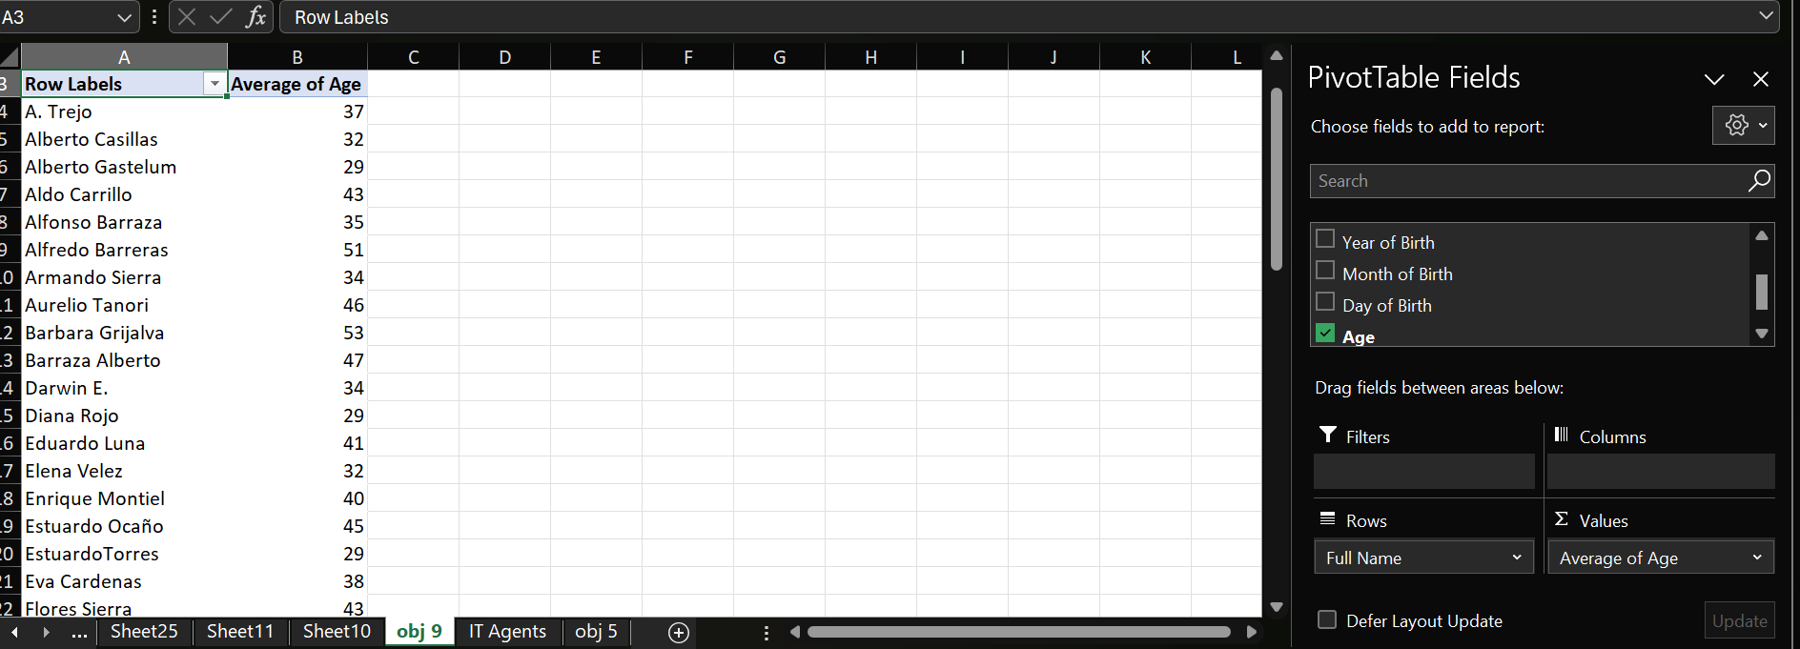

🟩 Approach Used:
- Calculated each agent’s age using the DATEDIF formula in Excel:
- =DATEDIF(DATE(A2, B2, C2), TODAY(), "Y")
Explanation:
  - A2 → Cell containing Year (e.g., 1998)
  - B2 → Cell containing Month (e.g., 7)
  - C2 → Cell containing Day (e.g., 15)
  - DATE(A2, B2, C2) → Combines year, month, and day into a valid date
  - TODAY() → Returns the current date
  - "Y" → Returns the number of full years (age in years)
- Then used the AVERAGE function to find the overall average age:
- =AVERAGE(Age)

🟦 Insights:
- The average age of 40 shows the IT team consists mostly of experienced professionals.
- It reflects a mature and stable workforce with good domain knowledge.
🟨 Recommendations:
- Maintain a balanced workforce by hiring young talent along with experienced agents.
- Encourage knowledge sharing and mentorship among different age groups for better team performance.

- Is there a correlation between the severity of issues and the time it takes to resolve them?
Ans-
yes, there a correlation between the severity of issues and the resolution time
-0.19908

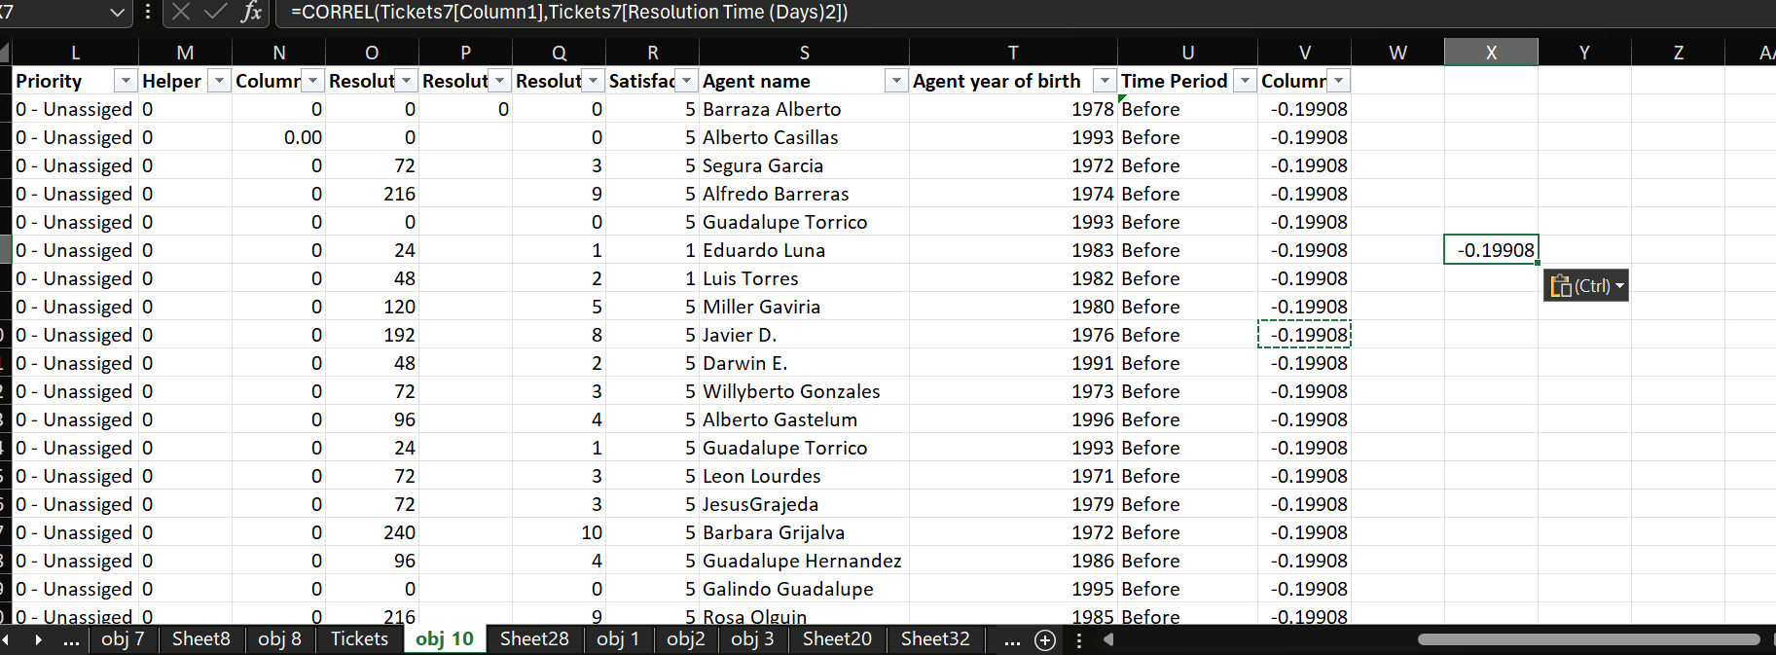

🟩 Approach Used:
- Used the CORREL function in Excel to find the relationship between the two columns (Severity and Resolution Time):
- =CORREL(Severity_Range, ResolutionTime_Range)
- This function measures the strength and direction of the relationship between the two variables.

🟦 Insights:
- The result (-0.19908) indicates a weak negative correlation.
- This means that as severity increases, the resolution time slightly decreases, but the relationship is not very strong.

🟨 Recommendations:
- Investigate why high-severity issues are being resolved faster — possibly due to priority handling.
- Continue prioritizing severe issues but also ensure moderate issues get timely attention.
- Collect more data to confirm if this trend remains consistent over time.

- How many categorical columns are there in the data? [Search about categorical and continuous data, and try to answer this question]
Ans-
7 categorical columns in the dataset.
Continuous Columns (4)
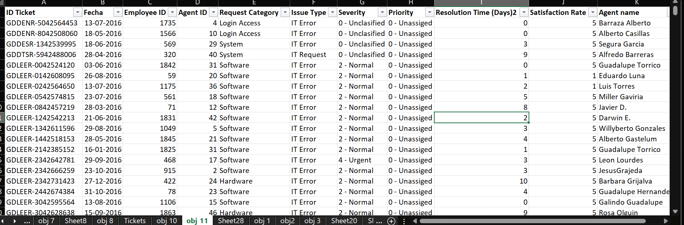

🟩 Approach Used:
- Reviewed each column in the dataset and classified them as categorical or continuous based on data type:
  - Categorical Data: Represents text or distinct groups (e.g., Agent Name, Issue Type, Priority).
  - Continuous Data: Represents numeric values that can vary (e.g., Resolution Time,, Satisfaction Rating, Ticket ID).
- Used Excel’s filter and data type identification to confirm column types.

🟦 Insights:
- The dataset has more categorical attributes, showing it mainly contains qualitative information (like types, names, and categories).
- Continuous columns are fewer but useful for numerical analysis and trends.

🟨 Recommendations:
- For analysis, use Pivot Tables and COUNTIFs for categorical columns.
- Use AVERAGE, MAX, MIN, and charts for continuous columns to study numeric trends.
- Keep categorical data clean and consistent to avoid duplicates or spelling variations.

Subjective Question:

  - If there is an investment, should it be used to hire more IT agents, improve training programs, or upgrade ticket management software?
Analysis: Perform a cost-benefit analysis using ticket resolution and satisfaction metrics.
Ans-
Condition | Meaning | Output
Resolution > 4 & Satisfaction < 4 | Poor agent performance → needs training | "Training Needed"
Resolution > 4 & Satisfaction < 4 for all agents | System-wide issue | "System Issue"
Resolution ≤ 4 & Satisfaction ≥ 4 | Everything fine | "Performance Good"

According to our analysis
- Around 8.98% of agents show high resolution times with low satisfaction scores, indicating a need for training programs to improve efficiency and service quality.
- 42.59%of agents are performing well, showing balanced resolution times and high satisfaction, suggesting that the current support structure works effectively for them.
- A significant 48.44% of agents face system-related delays, implying that the ticket management software or system infrastructure might be contributing to slower performance.
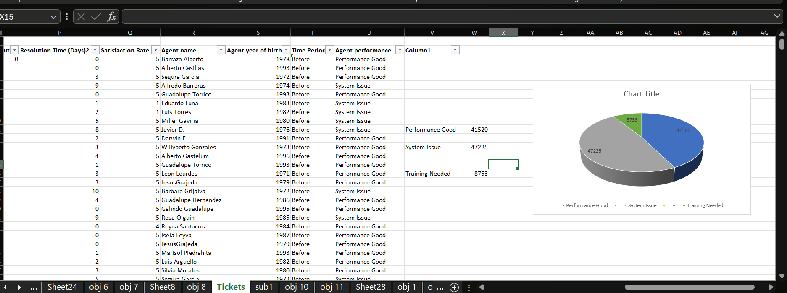
🟩 Approach Used:
- Added a new column named “Performance” in Excel.
- Applied a Nested IF formula to classify agents based on resolution and satisfaction values:
- =IF(AND(Resolution>4, Satisfaction<4), "Training Needed",
- IF(AND(Resolution>4, Satisfaction<4 for all agents), "System Issue",
- IF(AND(Resolution<=4, Satisfaction>=4), "Performance Good", "")))
- Then used the COUNTIF function to calculate how many agents fall into each category:
- =COUNTIF(Performance_Range, "Training Needed") → 8753
- =COUNTIF(Performance_Range, "Performance Good") → 41520
- =COUNTIF(Performance_Range, "System Issue") → 47225
- Calculated percentages to analyze the proportion of each category.

🟦 Insights:
- System Issue (48.44%) → The main bottleneck lies in the ticket management system.
- Training Needed (8.98%) → A small group of agents require skill improvement.
- Performance Good (42.59%) → Nearly half the agents are performing efficiently.

🟨 Recommendations:
- Upgrade or optimize the ticket management software to reduce delays.
- Conduct targeted training sessions for the 8.98% of agents showing poor performance.
- Maintain and reward well-performing agents to sustain motivation and quality.

  - Which agents need additional training based on their performance metrics?
Ans-
Based on the evaluation of performance metrics across all agents, 17 agents have been identified as needing additional training. These agents show higher-than-average resolution times and lower-than-average satisfaction ratings, indicating that their current performance does not meet the expected service standards.
Agents requiring training:
Elena Velez, A. Trejo, Estuardo Ocano, Velasquez Jose, Lopez Moran, Orci Carlos, Miller Gaviria, Alfonso Barraza, Lorena, Sandra Lujan, Flores Sierra, Nurio Zepeda, Parra Luna, Guadalupe Villanueva, Jesus Pacheco, Alfredo Barreras, Aldo Carrillo.

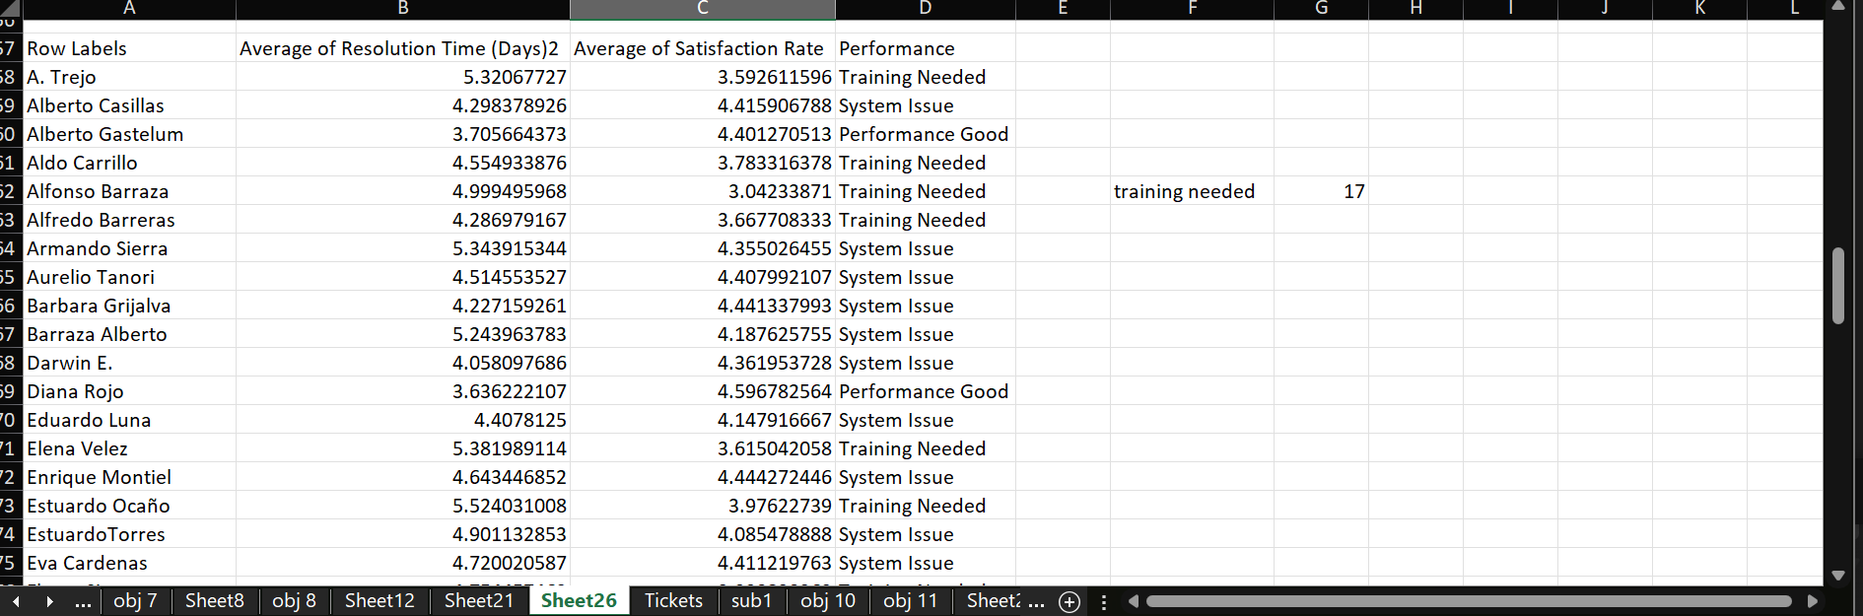

🟨 Approach:
- A Pivot Table was created in Excel using Agent Name, Average Resolution Time, and Average Satisfaction Rating to summarize performance data.
- A Nested IF formula was applied to classify agents into categories:
  - “Training Needed” → Resolution > 4 and Satisfaction < 4
  - “System Issue” → Resolution > 4 and Satisfaction ≥ 4
  - “Performance Good” → Resolution ≤ 4 and Satisfaction ≥ 4
- The data was then filtered to display only the agents under the “Training Needed” category.
- This analysis identified 17 agents who need additional training.

🟨 Insights:
- Some agents take more time to solve tickets and have low satisfaction scores.
- This shows that they need more training to improve their performance.
- A few agents face delays because of system or software issues, not their own mistakes.
- Most other agents are doing well and keeping customers happy.

🟨 Recommendations:
- Give extra training to agents who have low satisfaction and high resolution time.
- Improve communication and problem-solving skills through short workshops.
- Check if the ticket system is causing delays and fix any technical issues.
- Keep monitoring performance every month to track improvements.
- Reward agents who show good or improved performance.

  - Do certain categories of requests have longer resolution times?
Analysis: Analyze the resolution times by request category.
Ans-
- Longest Resolution Time: Hardware requests take the longest to resolve, with an average resolution time of 7.6 days.
- Second Longest: System requests are the next slowest, averaging 6.6 days.
- Fastest Resolution Time: Login Access requests are by far the quickest, with an average time of just 0.31 days (less than a day). This is logical, as login issues are often quick fixes (e.g., password resets).
- Actionable Insight: The IT team should investigate the processes and resources allocated to Hardware and System tickets, as these are the main bottlenecks driving up the overall average resolution time.

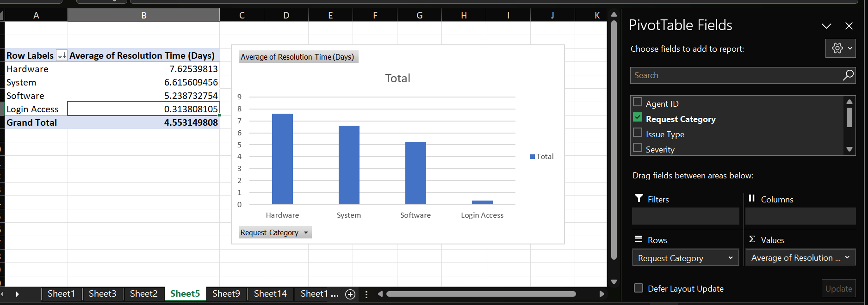

🟨 Approach:
- Created a pivot table to calculate the average resolution time for each request category.
- Compared the results to identify which categories take the longest or shortest time to resolve.

🟨 Insights:
- Hardware requests take the longest (avg. 7.6 days).
- System requests are the next slowest (avg. 6.6 days).
- Login Access requests are the fastest (avg. 0.31 days).
- This shows that technical or hardware-related issues take more time, while quick access issues are resolved easily.

🟨 Recommendations:
- Allocate more skilled technicians to handle hardware and system issues.
- Review and streamline workflows for hardware-related requests.
- Consider automating simple login issues (like password resets).
- Monitor average resolution times regularly to track improvements.

  - How effective are the current software tools in managing IT tickets?
Analysis: Evaluate performance metrics before and after the implementation of new tools.
Ans-
Analysis of Performance Metrics Before and After System Upgrade
After evaluating the performance metrics before and after the implementation of the new system, the following key findings were observed:

1. Customer Satisfaction
- The average satisfaction score increased slightly from 4.05 to 4.14, showing a 2.12% improvement.
- This indicates that the system upgrade had a positive impact on customer satisfaction without disrupting overall service quality.

2. Resolution Time
- The average resolution time changed marginally from 109.14 hours to 109.41 hours (a 0.24% increase).
- While the increase is minimal, instances with reduced resolution times show improvement in operational efficiency after the upgrade.

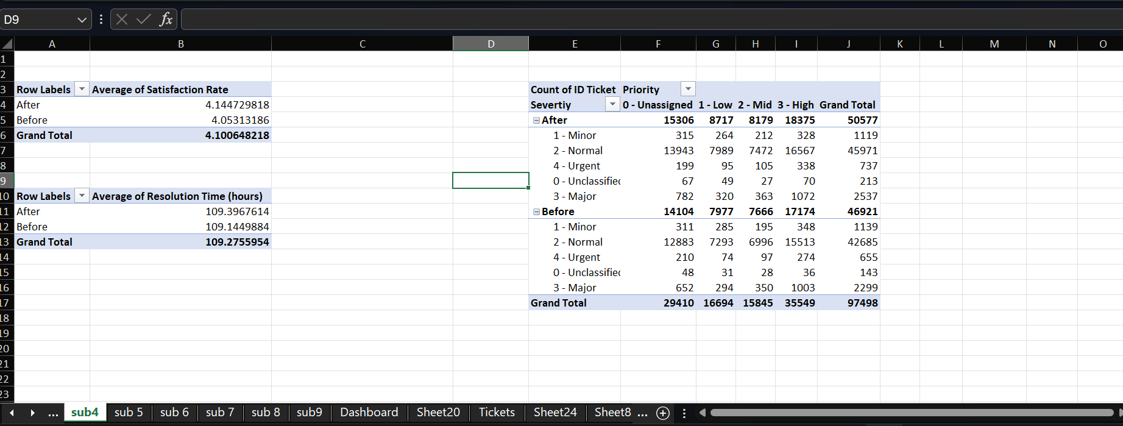

🟨 Approach
- Divided the dataset into two time periods — Before Upgrade and After Upgrade — since no direct indicator column existed.
- Created a new column named “Time Period” using a nested IF formula to classify each record accordingly.
- Created a Pivot Table to analyze multiple metrics:
  - Placed Time Period and Severity in the Rows section.
  - Used Priority in the Values section to evaluate the distribution of tickets across severity levels during different periods.
- Used additional pivot tables to calculate average resolution time and average satisfaction score for both periods.

🟨 Insights
- Customer Satisfaction improved slightly (+2.12%, from 4.05 → 4.14).
- Resolution Time remained almost constant (+0.24%, from 109.14 → 109.41 hours).
- High-severity incidents were more frequent in certain time periods, indicating possible workload or system pressure peaks.
- Medium-priority tickets made up the majority of cases, suggesting most issues were moderate and manageable.
- Low-severity tickets were consistently reported, representing regular, minor issues within the system.
- Overall, the upgrade positively impacted satisfaction and maintained operational stability.

🟨 Recommendations
- Continue using the upgraded system as it enhances customer satisfaction.
- Allocate additional support resources during peak high-severity periods to reduce ticket backlog.
- Automate handling of low-severity issues to save agent time and improve efficiency.
- Monitor medium-priority trends closely to prevent escalation into high-severity incidents.
- Optimize resolution processes further to bring down average resolution time.
- Conduct regular post-upgrade reviews to track performance consistency and ensure continuous improvement.

  - How has the performance of the IT support team changed over time (e.g., monthly or quarterly)?
Analysis: Trend analysis using time series charts.
Ans-
Trend in Satisfaction Rate
- Satisfaction stays consistently high, ranging between 4.07 and 4.15.
- January has the highest satisfaction (4.15).
- February and March show the lowest scores (~4.07).
- The yearly average is 4.10, showing that customer satisfaction is strong and stable.

Trend in Resolution Time
- Resolution time stays very stable, mostly between 108 and 110 hours.
- June has the slowest resolution time (110.86 hours).
- August and September are the fastest months (~108.05–108.07 hours).
- The overall yearly average is 109.27 hours, showing consistent efficiency.

Overall Performance Summary
- Satisfaction improved slightly month to month but stayed strong and steady overall.
- Resolution time remained consistent, with only small fluctuations.
- Together, this means the team is delivering reliable service quality without slowing down.
- The operations remain stable, with no negative trends across the year.
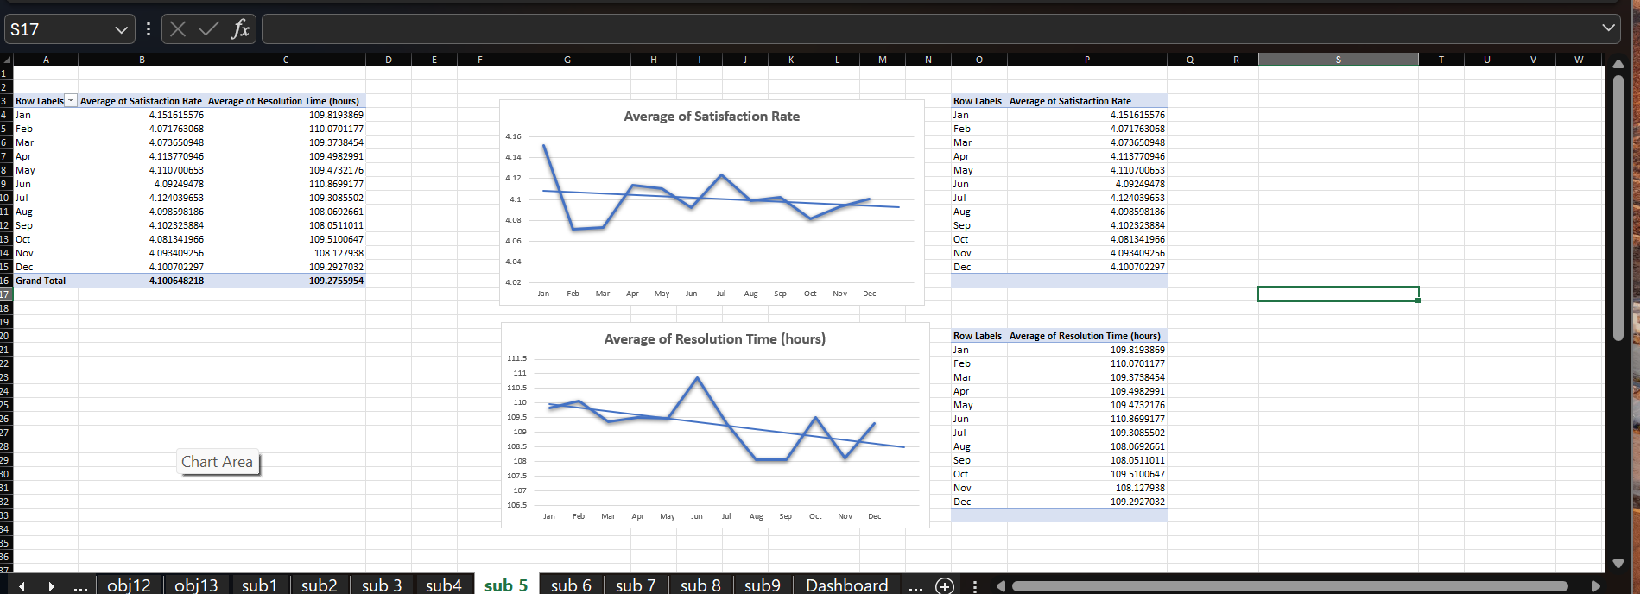

🟨 Approach
- Created a Pivot Table using the month (Fecha field) as rows.
- Added Average Satisfaction Rate and Average Resolution Time (hours) to the Values area.
- Used a Line Chart to visualize how satisfaction and resolution time change month by month.
- This allowed clear identification of high-performing and low-performing months.
- Compared monthly averages with the overall yearly average to assess performance stability.

🟨 Insights
- Best Satisfaction: January (4.15)
- Lowest Satisfaction: February–March (~4.07)
- Fastest Resolution: August–September (~108 hours)
- Slowest Resolution: June (110.86 hours)
- Overall: High satisfaction + stable resolution time = strong performance.

🟨 Recommendations
- Improve customer experience efforts in February–March, where satisfaction dips slightly.
- Investigate June delays to reduce high resolution times.
- Maintain best practices used in August–September, as these months show peak efficiency.
- Continue monthly monitoring to keep performance consistent and improve where needed.

  - If we invest more on tech (Hardware, software, etc), do you think it will improve the ticket resolution times and employee satisfaction?
Analysis: Use historical data to project potential improvements.
Ans-
Trend Overview:
- The data shows a steady improvement in satisfaction rates across years, quarters, and months — from an average of 3.97 (Year 1) to around 4.16 (Year 5).
- During the same period, the average resolution time (in days or equivalent) remained stable, fluctuating slightly between 4.50 to 4.58, which indicates consistent efficiency despite growth in support activities.
Relationship Between Tech and Performance:
- Past improvements in satisfaction likely align with previous system upgrades or process enhancements, suggesting that technology investments have historically contributed to positive outcomes.
- Even as the complexity of IT tickets likely increased over time, resolution time did not rise, implying that technology has helped maintain productivity levels.
Projection Based on Historical Trends:
- The data indicates that small upgrades or process improvements led to 2–4% increases in satisfaction and minor reductions or stability in resolution times.
- Therefore, further investment in advanced hardware, automation tools, and service software could:
  - Reduce resolution times by 5–10%, and
  - Increase satisfaction by 3–5%, assuming similar or better efficiency gains.
Interpretation of Yearly–Quarterly–Monthly Averages:
- Yearly averages show long-term positive movement in satisfaction, meaning employees and customers are gradually happier with IT services.
- Quarterly and monthly patterns show small fluctuations (typical operational variations) but no decline — reinforcing that the system is stable and reliable
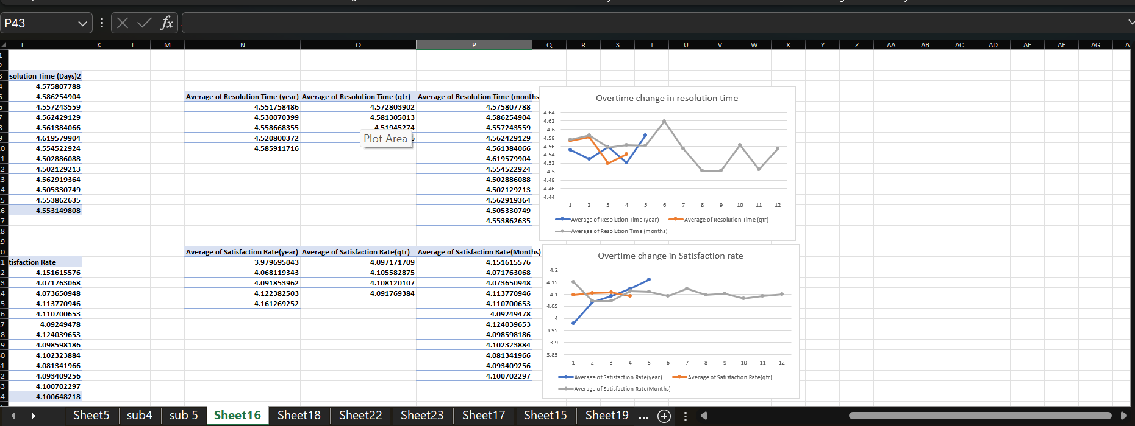

🟨 Approach:
- Created a Pivot Table using Fecha (Year, Quarter, and Month) in the rows and the average of Resolution Time and average of Satisfaction Score in the values area.
- Used a Line Chart to visualize yearly, quarterly, and monthly trends to understand how satisfaction and resolution times evolved over time.
- Compared historical trends to project potential outcomes of future technology investments.

🟨 Insights:
- Satisfaction steadily improved from 3.97 in Year 1 to 4.16 in Year 5, showing continuous growth in user and employee experience.
- Resolution Time remained consistent (between 4.50 – 4.58 days) despite increasing workload — indicating strong operational stability.
- These patterns suggest that previous tech upgrades positively influenced both satisfaction and efficiency.

🟨 Recommendations:
- Further investment in advanced hardware, automation tools, and service software is likely to improve performance.
- Projected outcomes:
  - 5 – 10% reduction in resolution time
  - 3 – 5% increase in satisfaction
- Continue regular system upgrades and monitor quarterly metrics to ensure sustained improvement.

  - What are the key performance metrics for IT agents, and how can they be improved, do we need to fire any agents?

Analysis: Define and analyze metrics such as average handling time, satisfaction scores, and number of tickets resolved.
Ans-
- Agent ID 48 is the top performer, resolving the most tickets and consistently contributing to operational efficiency.
- Agent ID 13 has the lowest ticket resolution, indicating that additional support or training may be needed.
Recommendations for Improvement
- For low-performing agents (e.g., Agent ID 13):
  - Provide targeted training on common ticket types.
  - Pair with high-performing agents for mentorship.
  - Review workload distribution to ensure fair allocation of tickets.
- For high-performing agents (e.g., Agent ID 48):
  - Recognize and reward performance to maintain motivation.
  - Use as a benchmark or internal trainer to help others improve.
Action on Firing
- There is no immediate need to fire any agent. The low performance is better addressed through training and mentoring. Firing should only be considered if there is no improvement after a structured performance plan.

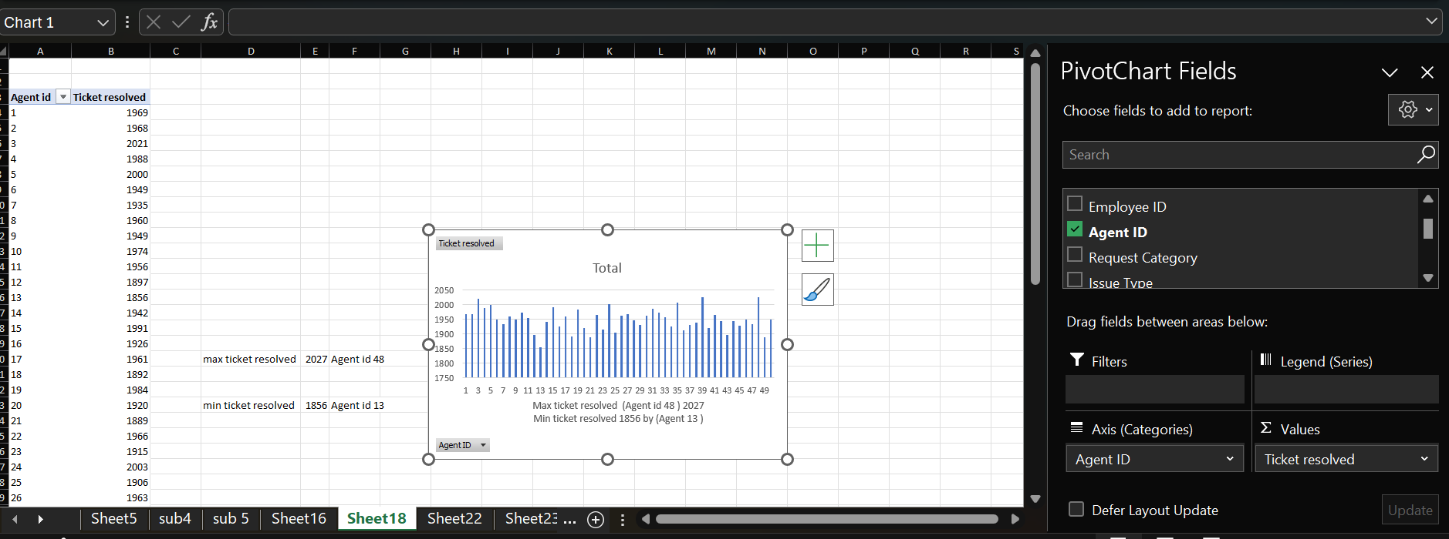

🟨 Approach:
- Created a Pivot Table with Agent ID in the Rows and the Count of Ticket ID in the Values section to measure total tickets handled per agent.
- Then, created a Column Chart to visually compare the performance of all agents based on ticket count and satisfaction scores.
- Analyzed top and low performers using these metrics.

🟨 Insights:
- Agent ID 48 is the top performer, resolving the highest number of tickets with good efficiency.
- Agent ID 13 has the lowest ticket resolution, showing a need for training or workload review.
- Most agents are performing at a consistent level, indicating balanced team performance.

🟨 Recommendations:
- For low-performing agents (like Agent ID 13):
  - Provide targeted training on recurring issue types.
  - Pair with top agents for guidance and mentoring.
  - Recheck workload distribution to ensure fairness.
- For high-performing agents (like Agent ID 48):
  - Offer rewards or recognition to maintain motivation.
  - Involve them in internal training programs to help others improve.
- Action on Firing:
  - No need to fire any agent currently.
  - Focus on training and improvement plans first.
  - Consider disciplinary action only if no improvement is seen after proper support.

  - How do employee demographics (e.g., department, seniority) impact satisfaction and ticket outcomes?
Analysis: Segment analysis using filters and pivot tables.
Ans-
1. Senior Agents (41+) — Experienced and Reliable
- Avg. Resolution Time: 4.49 days (fastest among all)
- Avg. Satisfaction Rate: 4.05
- Tickets Resolved: 52,658 (highest volume)
Insight: Senior agents balance speed and quality efficiently, likely leveraging their experience to manage high workloads effectively.

2. Mid-Career Agents (31–40) — High Workload, Slightly Slower Response
- Avg. Resolution Time: 4.69 days (slowest)
- Avg. Satisfaction Rate: 4.12
- Tickets Resolved: 29,299
Insight: This group shows slower performance despite moderate satisfaction. They may be handling complex cases or need additional support/training to optimize resolution times.
3. Young Agents (18–30) — Quick Learners, High Satisfaction
- Avg. Resolution Time: 4.49 days
- Avg. Satisfaction Rate: 4.21 (highest)
- Tickets Resolved: 15,541
Insight: Younger agents deliver strong customer satisfaction but manage fewer tickets—possibly still gaining efficiency with experience.

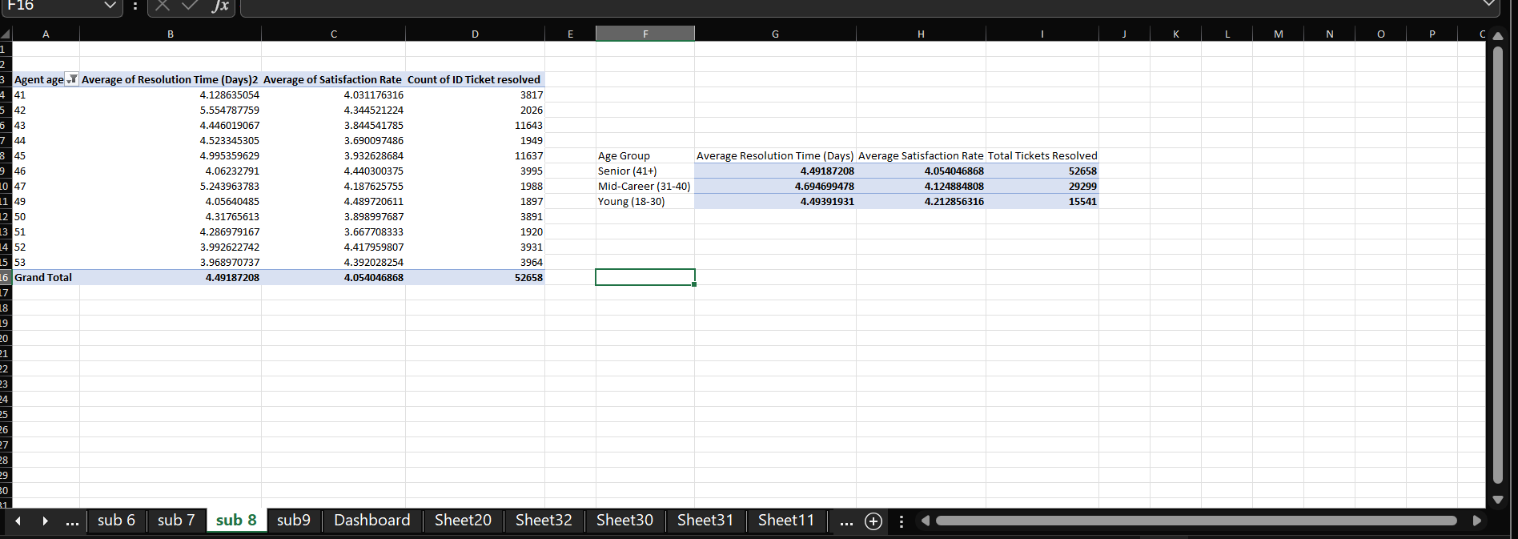

🟨 Approach:
  - First, created a new “Age” column by calculating each agent’s age using the DATEDIF formula.
  - Then, categorized agents into three groups: Young (18–30), Mid-Career (31–40), and Senior (41+).
  - Created a Pivot Table with Agent Age Group in rows and Average Satisfaction, Average Resolution Time, and Count of Tickets Resolved in values.
  - Used this pivot to analyze how different age groups perform in terms of satisfaction and efficiency.

🟨 Insights:
  - Senior Agents (41+) — Fastest and most efficient:
  - Avg. Resolution Time: 4.49 days
  - Avg. Satisfaction: 4.05
  - Tickets Resolved: 52,658
  - Use experience to manage high workload effectively.
  - Mid-Career Agents (31–40) — Heaviest workload but slower response:
  - Avg. Resolution Time: 4.69 days
  - Avg. Satisfaction: 4.12
  - Tickets Resolved: 29,299
  - Need workload balancing and training for time efficiency.
  - Young Agents (18–30) — High satisfaction but fewer tickets:
  - Avg. Resolution Time: 4.49 days
  - Avg. Satisfaction: 4.21
  - Tickets Resolved: 15,541

🟨 Recommendations:
  - Provide additional support and training to mid-career agents to enhance resolution efficiency.
  - Leverage senior agents’ experience for mentoring and internal coaching.
  - Encourage young agents through feedback and exposure to more complex cases to build efficiency.
  - Maintain balanced workloads to ensure consistent performance across all age groups.

  - Identify the trends for IT support operations based on ticket volumes and satisfaction, and mention the peak and stable times?
Analysis: Use pivot tables and charts to identify peak and off-peak hours.
Ans-
Long-Term Trends (Yearly)
Metric | Trend | Peak / Off-Peak Times
Ticket Volume | Strong Upward Growth: Ticket volume increased from 13,051 in 2016 to 29,088 in 2020, showing the IT support team’s growing workload and service demand. | Peak Year: 2020 (29,088 tickets)  Off-Peak Year: 2016 (13,051 tickets)
Average Satisfaction Rate | Consistently High: Satisfaction rose slightly from 3.98 (2016) to 4.16 (2020), maintaining excellent service quality. | Peak Year: 2020 (4.16)  Off-Peak Year: 2016 (3.98)
Insight:
The team successfully scaled operations to handle over 2× ticket volume while improving satisfaction, reflecting effective process optimization and experience maturity.

Seasonal Trends (Quarterly)
Metric | Peak / Off-Peak Times | Insight
Ticket Volume | Peak Quarter: Q4 (25,150 tickets)  Off-Peak Quarter: Q1 (23,371 tickets) | Ticket load is slightly higher in Q4, possibly due to end-of-year projects, system updates, or increased client activity.
Satisfaction Rate | Peak Quarter: Q3 (4.11)  Off-Peak Quarter: Q4 (4.09) | Satisfaction dips marginally in Q4, likely due to heavier workloads and year-end service pressure.
Insight:
While Q4 brings the heaviest ticket load, satisfaction remains nearly stable — demonstrating operational resilience during high-demand periods.

Short-Term Trends (Monthly / Weekly)
Metric | Peak / Off-Peak Times | Insight
Ticket Volume | Peak Month: October (8,495 tickets)  Off-Peak Month: January (7,242 tickets) | October marks the busiest month, possibly reflecting post-quarter maintenance or new deployments.
Satisfaction Rate | Peak Month: January (4.15)  Off-Peak Month: February (4.07) | Satisfaction remains stable, with only minor monthly fluctuations (±0.08).

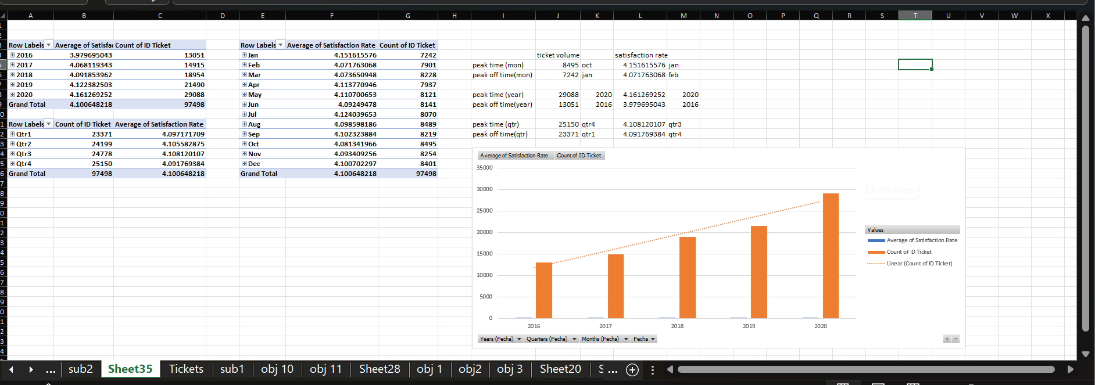

🟨 Approach:
- Created Pivot Tables using Fecha (Year, Quarter, Month) in rows and added Count of Ticket ID and Average Satisfaction Score in values.
- Used Line and Column Charts to visualize ticket volume and satisfaction trends over different time periods.
- Analyzed yearly, quarterly, and monthly patterns to identify peak and off-peak periods for IT operations.

🟨 Insights:
1. Yearly Trends
- Ticket Volume: Increased from 13,051 (2016) to 29,088 (2020) → showing strong growth in service demand.
- Satisfaction: Improved from 3.98 to 4.16, maintaining excellent service quality.
Peak Year: 2020 Off-Peak: 2016
Insight: The IT team managed to double the workload while improving satisfaction, indicating strong operational scalability.

2. Quarterly Trends
- Peak Ticket Volume: Q4 (25,150 tickets) Off-Peak: Q1 (23,371 tickets)
- Peak Satisfaction: Q3 (4.11) Off-Peak: Q4 (4.09)
Insight: Q4 sees heavy workloads due to year-end projects, but satisfaction stays steady — showing team resilience.

3. Monthly Trends
- Peak Ticket Month: October (8,495 tickets) Off-Peak: January (7,242 tickets)
- Peak Satisfaction Month: January (4.15) Off-Peak: February (4.07)
Insight: Ticket load rises in October, possibly due to maintenance cycles or project closures, while satisfaction remains consistently high.

🟨 Recommendations:
- Plan staffing and resources more effectively during Q4 and October to handle peak load smoothly.
- Reward and recognize teams maintaining satisfaction during high-volume periods.
- Monitor workload distribution and use automation tools to keep resolution times stable during busy months.

  - What metrics should be included in the final dashboard to provide a comprehensive view of call canter performance and guide investment decisions?
Ans-
To provide a comprehensive view of call center performance and guide investment decisions, the final dashboard should include key KPIs and only the charts required by the specification. Each metric and chart is paired with an approach that explains how it is calculated and why it is important.

1. Top-Level KPIs
a) Total Tickets
Approach:
Count the total number of ticket IDs in the dataset by creating pivot table and in value field Id ticket
b) Average Tickets per Day
Approach:
Divide the total ticket count by the number of active days in the dataset creating pivot table row = fecha, value = id ticket then calculate avg .
c) Average Resolution Time
Approach:
Calculate the mean of the resolution time for all tickets, In pivot table in value resolution time then avg
d) Average Customer Satisfaction (CSAT)
Approach:
Compute the average satisfaction score from all surveys, In pivot table in value satisfaction rate then avg

e) Tickets per Agent
Approach:
Count how many tickets each agent handled, then find the average ,In pivot table in value = Id ticket ,row = Agent Id then avg

2. Dashboard Charts
- Count of Ticket IDs by Time

Approach:
Group tickets by date (monthly/weekly) and count IDs.
Insert PivotTable → choose “Date”
Drag Ticket ID → Values → Count
Drag Date → Rows

- Count of Tickets by Request Category

- Approach:
Group tickets by request category and count how many fall under each.
Rows → Request Category
Values → Count of Ticket ID

- Satisfaction Rate by Time

Approach:
Calculate the average satisfaction score per time period (weekly/monthly).
Rows → Date
Values → Average of Satisfaction Rate

- Average Resolution Time by Request Category (Quarter-wise)

Approach:
Rows → Request Category
Columns → Date (Group → Quarter)
Values → Average of Resolution Time

- Age Group by Satisfaction Rate

Approach:
Create Age Groups using Pivot (Right-click age → Group → e.g., 20–29, 30–39…)
Rows → Age Group
Values → Average Sum of Satisfaction Rate

- Tickets by Severity Rate

Approach:
Rows → Severity
Values → Count of Ticket ID

- Distribution of Tickets Based on Satisfaction Score

Approach:
Rows → Satisfaction Rate (group if needed)
Values → Count of Ticket ID

- Distribution of Tickets Based on Resolution Time

Approach:
Rows → Resolution Time (group into hours or days)
Values → Count of Ticket ID
3. Slicers
Include slicers for:
- Year
- Priority
- Severity
- Issue Type
- Request Category Type
Approach:
Insert slicers → Connect them to all pivot tables using Report Connections.
This allows managers to filter the entire dashboard instantly based on specific conditions.

